HANOI UNIVERSITY OF SCIENCE AND TECHNOLOGY

School of Information and communications technology

**Network Programming**

**❧ • ❧**



**Group 10 report**

**Topic : FUNGAME**

**Group’s members:**

|  |  |
| --- | --- |
| **Name** | **MSSV** |
| 1. Đặng Việt Anh | 20176686 |
| 2. Nguyễn Minh Tú | 20154203 |

**Supervisor:**Dr. Trần Nguyên Ngọc

**Hanoi, May, 2021**

**Table of contents**

**Prologue ………………..……………………………………………1**

1. **Introduction…………………………………………….…………2**
2. **Design Analysis ………………………………..………….………3**
3. **Function …..………………………………………..…….………7**
4. **Technique………………………………………….………….….10**
5. **Evaluate………………………..…………………………………14**
6. **Work Contribution ……………..………………………………14**
7. **Conclusion……….…………………………………...….………14**
8. **References………..………………………………………………14**

# **Prologue**

First of all, we would like to sincerely thank the enthusiastic help and teaching of teacher Tran Nguyen Ngoc. Thanks to the knowledge in the practical network programming subject and comments in progress presentations, we have completed the topic Fun Game within the framework of the course report.

In progress of working, shortcomings in the process of implementation and synthesis are inevitable. We hope to receive your comments and guidance for better performance.

# **Introduction**

Our group tend to build traditional games: Tic Tac Toe game and Caro game. This games are both for entertainment and improving thinking ability of players.

This games is built network programming with basic functions like

play games, view ranking, view log, etc. In technique, we use Minimax

algorithm for cpu player, hiding password by termios.h library and

timeout value.

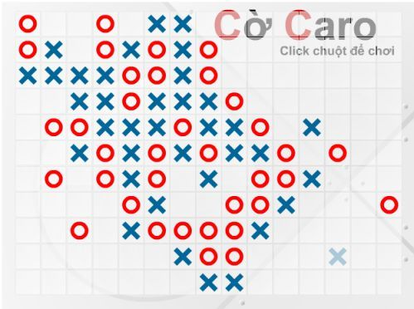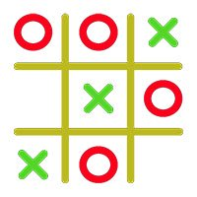 Caro Game Tic Tac Toe Game

# **Design analysis**

* Use case diagram

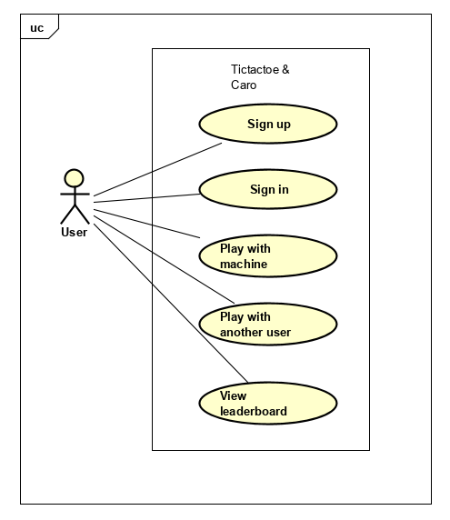

* Server-Client architecture

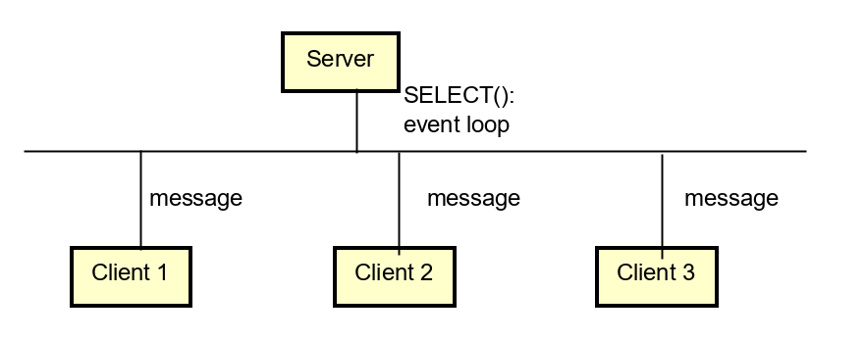

Fig: Client-Server architecture

* Event- driven socket program
* Server sits on an event loop
* Clients’ messages are handled upon arrival
* Server-Client model: Many clients connect to one server
* Singly linked list:

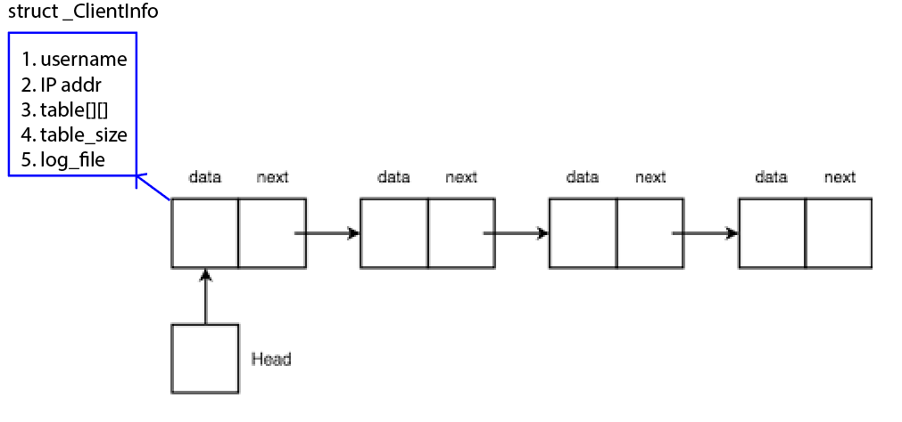

* Server uses this list to store current games of different clients
* Operations: new, get, add, remove
* Communication Protocol:

Messages between clients and server are in form: SIGNAL#PARAM1#PARAM2…

|  |  |  |
| --- | --- | --- |
| Signal | Param | Explaination |
| SIGNAL_CARO_NEWGAME | None | Client requests a new caro game |
| SIGNAL_CREATEUSER | Username#Password | Client wants to sign up with given name & password |
| SIGNAL_CARO_WIN | None | Server notifies client that he/she has won |
| ... |  |  |

* Sign up

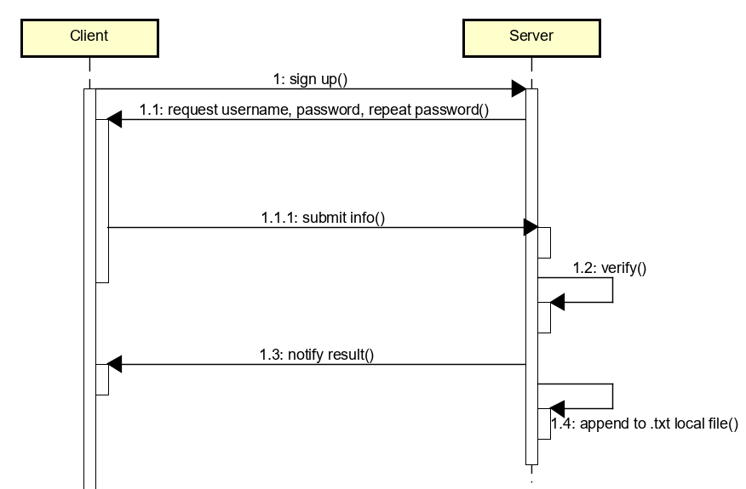

* Sign in

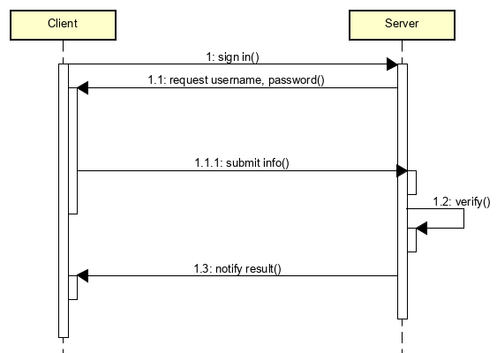

* Menu Navigation: Finite State Machine

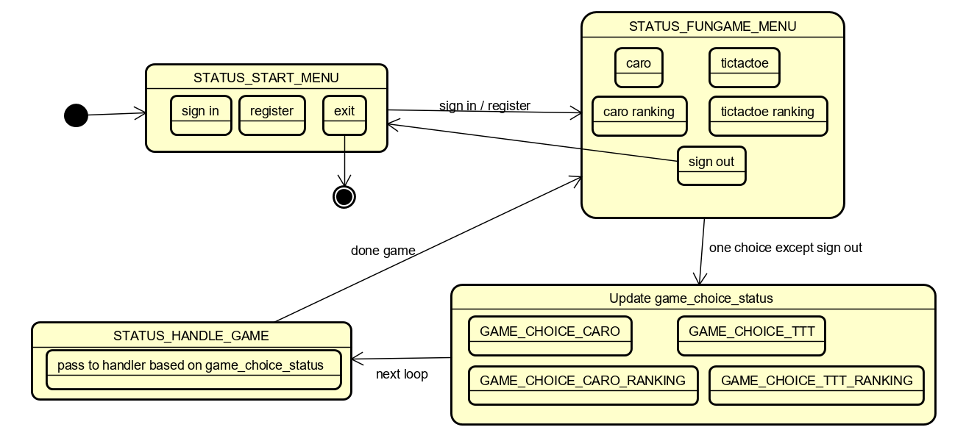

* Single player:

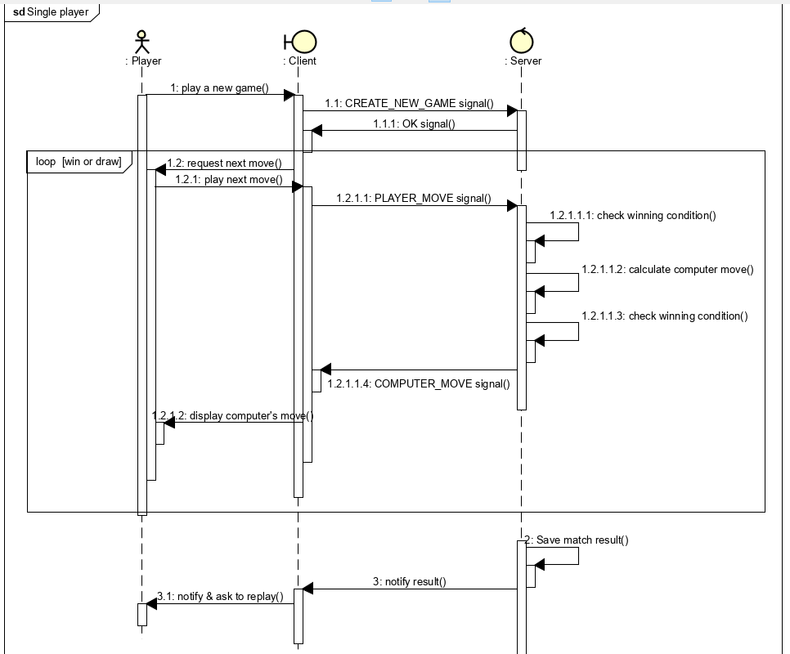

# **Function**

**3.1: Register new user**

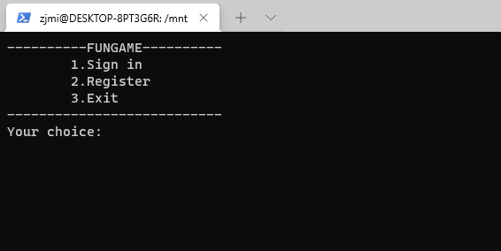

After clients connected to server, STATUS_START_MENU appear with 3 options, clients choose option 2 for register, after that they input username and hiding password.

**3.2: Sign in**

At STATUS_START_MENU, choosing option 1-> input username and password.

**3.3: Play game**

After sign in, STATUS_FUNGAME_MENU will appear.

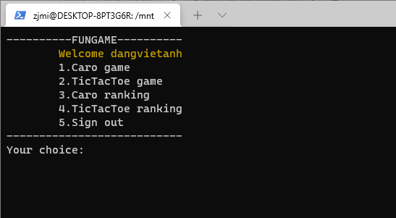

With option 1, we will play Caro game:

Next, we choose size of table Caro(from 15 to 25 pixels), then this table will appear:

After a time of play and finish, board will show up result and ask for viewing log:

With option 2, we will play Tic Tac Toe game:

Next, we choose order to play:

With option 3 and 4, we see ranking of games:

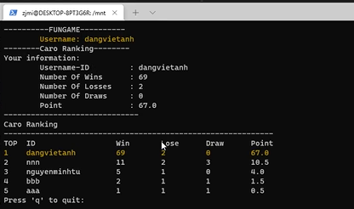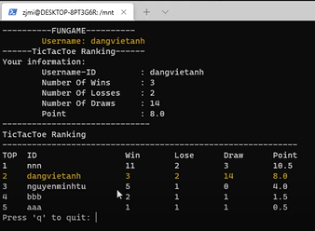

# **Technique**

**4.1 Minimax Algorithm**

**-** Concepts:

* Game tree is the model tree contain each state, case of game follow turn play
* Each node depicts one state of current game in game tree
* Node is called leaf which is at end of game(state is win, lose or tie)

- Minimax algorithm: Two player are represented by MAX and MIN. MAX always try to win and optimize play, meanwhile MIN try to make MAX get the smallest score. This algorithm perform by how to valuate each node in game tree: Node belonging to MAX is assigned max value and node belonging to MIN is assigned min value. From there, players have base to play next properly.

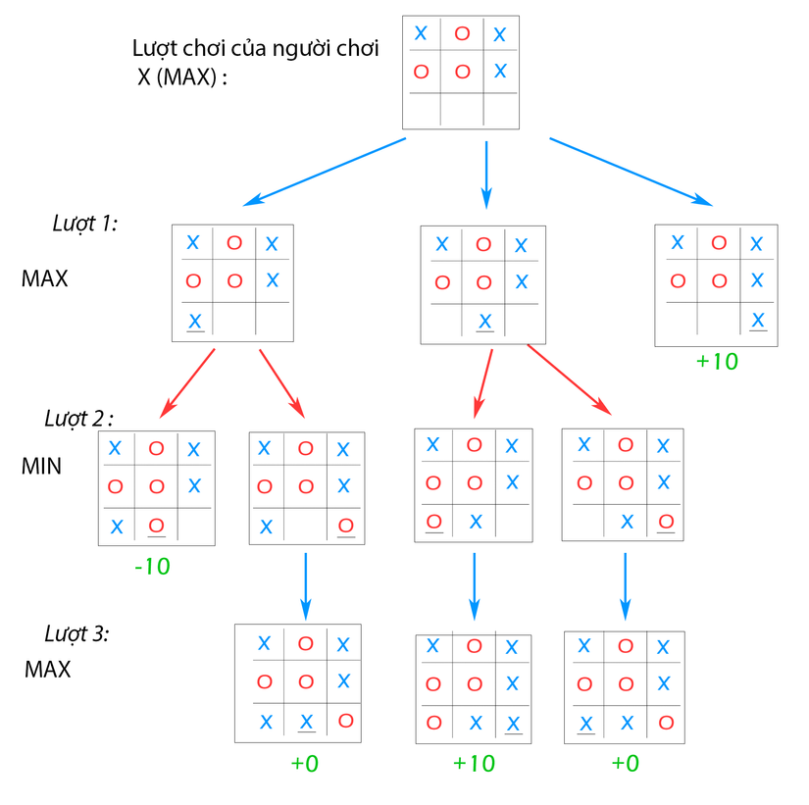

Follow the graph: First, we see that the current state of game is X’s turn(MAX). Our convention is when X win MAX = +10, X lose MIN = -10 and tie = 0. In turn 1, MAX has 3 ways. If MAX go to case 3, X win, if not we go next to next turns.

**4.2 TCP connection client side:**

//Step 1: Construct socket

if((sock = socket(AF_INET, SOCK_STREAM, 0)) == -1){

strcpy(error,"Error Socket!!!");

return -1;

}

//Step 2: Specify server address

server_addr.sin_family = AF_INET;

server_addr.sin_port = htons(PORT);

server_addr.sin_addr.s_addr = inet_addr(serverAddress);

// set timeout

struct timeval timeout;

timeout.tv_sec = 20; // after 20 seconds connect will timeout

timeout.tv_usec = 0;

if (setsockopt (sock, SOL_SOCKET, SO_RCVTIMEO, (char *)&timeout,

sizeof(timeout)) < 0){

return -1;

}

else if (setsockopt (sock, SOL_SOCKET, SO_SNDTIMEO, (char

*)&timeout, sizeof(timeout)) < 0){

return -1;

}

//Step 3: Request to connect server

if( connect(sock, (struct sockaddr*)&server_addr, sizeof(struct

sockaddr)) == -1){

errorConnect = errno;

sprintf(error,"Error! Can not connect to server!

%s",strerror(errorConnect));

return -1;

}

//Step 4: Communicate with server

send(sock, send_msg, strlen(send_msg), 0);

recieved = recv(sock, recv_msg, BUFF_SIZE, 0);

recv_msg[recieved] = '\0';

strcpy(send_msg, SIGNAL_CLOSE);

send(sock, send_msg, strlen(send_msg), 0);

close(sock);

if(recieved == -1){

printf("\nError: Timeout!!!\n");

return -1;

}

isCommunicating = 0; // ngat ket noi

return 0;

**4.3 TCP connection server side**

// Step 1: Construct a TCP socket to listen connection request

if((sock = socket(AF_INET, SOCK_STREAM, 0)) == -1) {

perror("Socket error\n");

exit(-1);

}

if(setsockopt(sock,SOL_SOCKET,SO_REUSEADDR,&true,sizeof(int)) == -1) {

perror("Setsockopt error\n");

exit(-2);

}

//Step 2: Bind address to socket

server_addr.sin_family = AF_INET;

server_addr.sin_port = htons(PORT);

server_addr.sin_addr.s_addr = INADDR_ANY;

bzero(&(server_addr.sin_zero),8);

if (bind(sock, (struct sockaddr *)&server_addr, sizeof(struct sockaddr)) == -1) {

perror("Unable to bind\n");

exit(-3);

}

//Step 3: Listen request from client

if (listen(sock, 5) == -1) {

perror("Listen error\n");

exit(-4);

}

printf("FUNGAME waiting for client on port %d\n", PORT);

fflush(stdout);

FD_SET(sock, &master);

fdmax = sock;

// Set timeout

struct timeval timeout;

timeout.tv_sec = 1000; // after 1000 seconds will timeout

timeout.tv_usec = 0;

//Step 4: Communicate with clients

while(1){

read_fds = master;

rc = select(fdmax + 1, &read_fds, NULL, NULL, &timeout);

if( rc == -1){

perror("select() error!\n");

exit(-6);

}

else if (rc == 0){

printf(" select() timed out. End program.\n");

exit(-5);

}

for(i = 0; i <= fdmax; i++){

if(FD_ISSET(i, &read_fds)){

if(i == sock){

sin_size = sizeof(struct sockaddr_in);

connected = accept(sock, (struct sockaddr*)&client_addr, &sin_size);

if(connected == -1){

perror("accept error!\n");

exit(-7);

}

else{

FD_SET(connected, &master);

if(connected > fdmax)

fdmax = connected;

printf("Got a connection from (%s , %d) with fd = %d\n", inet_ntoa(client_addr.sin_addr),ntohs(client_addr.sin_port), connected);

handleDataFromClient(connected);

}

}

else{

handleDataFromClient(i);

}

}

}

}

close(sock);

return 0;

**4.4 Other technique**

- Use library **termios.h** to hide password.

- Use timeout value for both server and clients.

# **Evaluate**

* Program have complete functions: Sign in, register, play game, view log, view ranking.
* Functions activate normal, stable.
* Solve timeout error: Set timeout for both clients and server.

# **Work Contribution**

|  |  |
| --- | --- |
| Đặng Việt Anh (50%) | Nguyễn Minh Tú (50%) |
| * Game logic * Finite state machine menu * Login-sign up logic | * Game interface * Design server-client communication |

# **Conclusion**

Above is all contents of our project, which are showed up from design analysis to complete program.

Video demo: https://youtu.be/9_IYJvR2kPI

Source code: https://github.com/GoodGuy69/caroPj.git

1. **References**

1. Slides of teacher Tran Nguyen Ngoc

2. "Unix-network-programming" ebook - W. Richard Stevens, Bill Fenner, Andrew M. Rudoff

3. Reference for termios.h library: <https://www.ibm.com/support/knowledgecenter/en/SSLTBW_2.1.0/com.ibm.zos.v2r1.bpxbd00/rttcga.htm>

4. Minimax algorithm: <https://viblo.asia/p/thuat-toan-minimax-ai-trong-game-APqzeaVVzVe>